PrimeNumber Mastery Assignment
Reflection Log
Stefan S
CSE 2140 2nd Language Programming
(PrimeNumber.java)
How has your program changed from planning to coding to now? Explain.
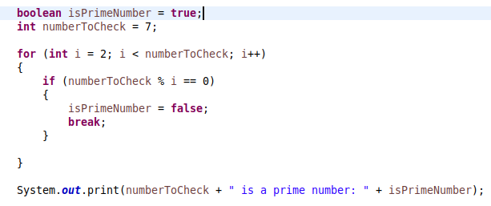
Earliest working version of the program. The loop starts at 2 because the remainder of anything divided by 1 will always be 0. We use < instead of <= for the loop’s condition, because the remainder of a number divided by itself will also always be 0.

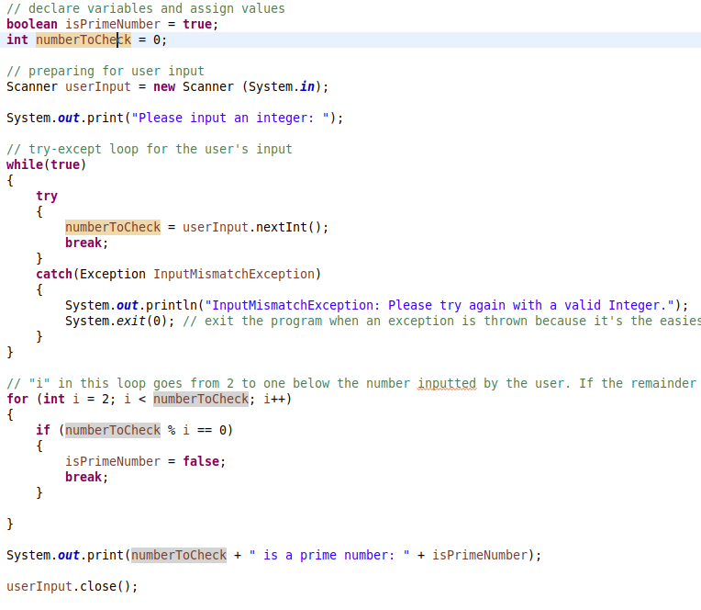
The final version of the program is largely the same, with some code to better handle the user’s input. This code is not different from what I planned in my IPO.

